**Sequence Diagram 1 – Add New Task**

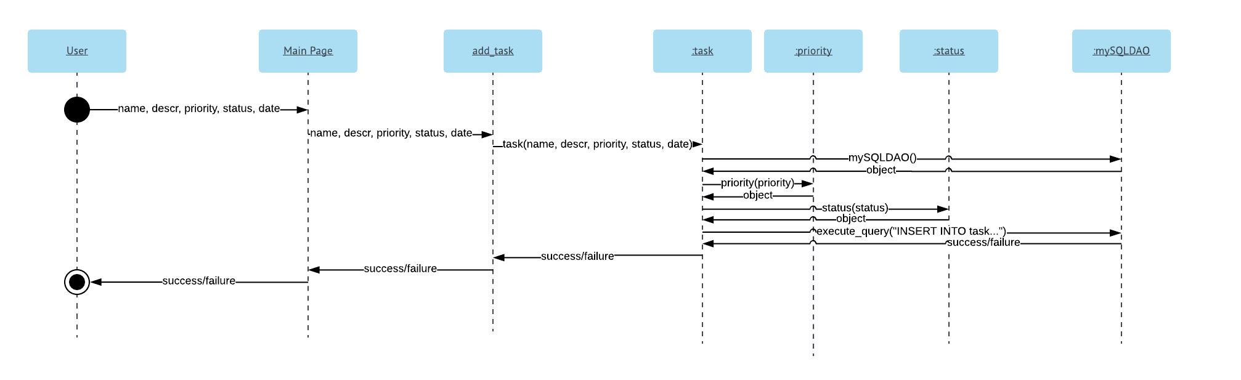

**Sequence Diagram 2 – Delete Task**

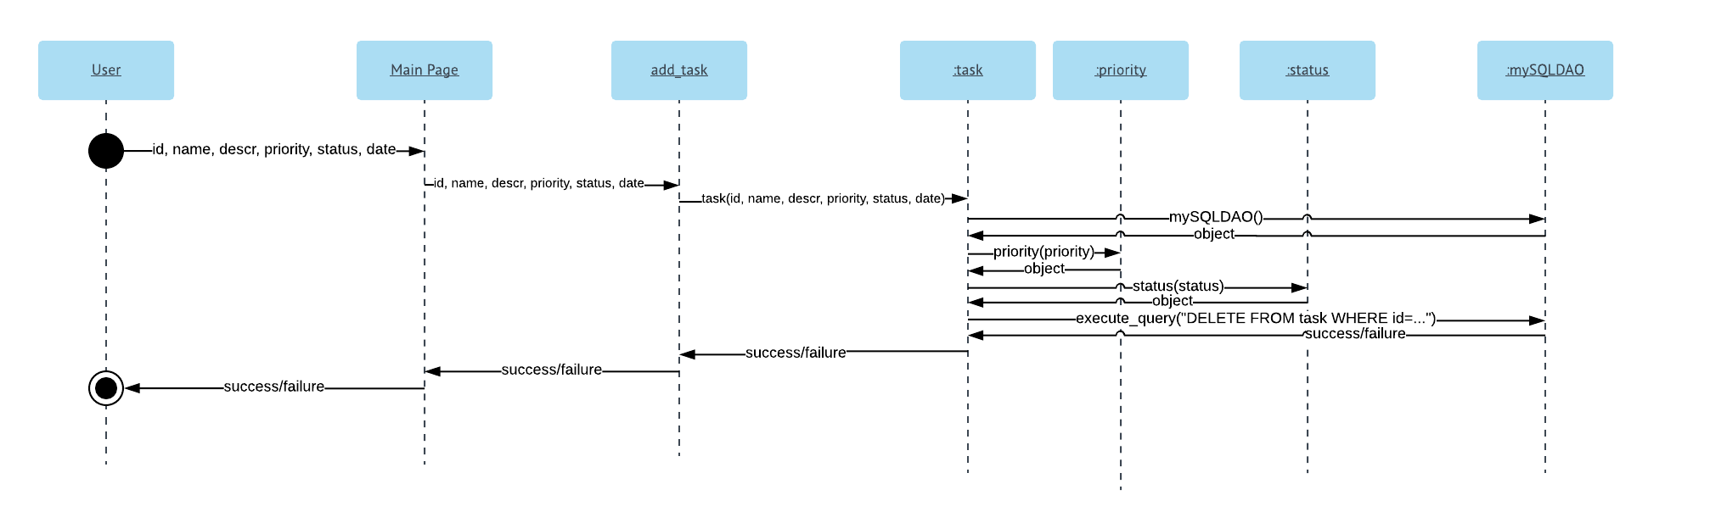

**Sequence Diagram 3 – Update Task**

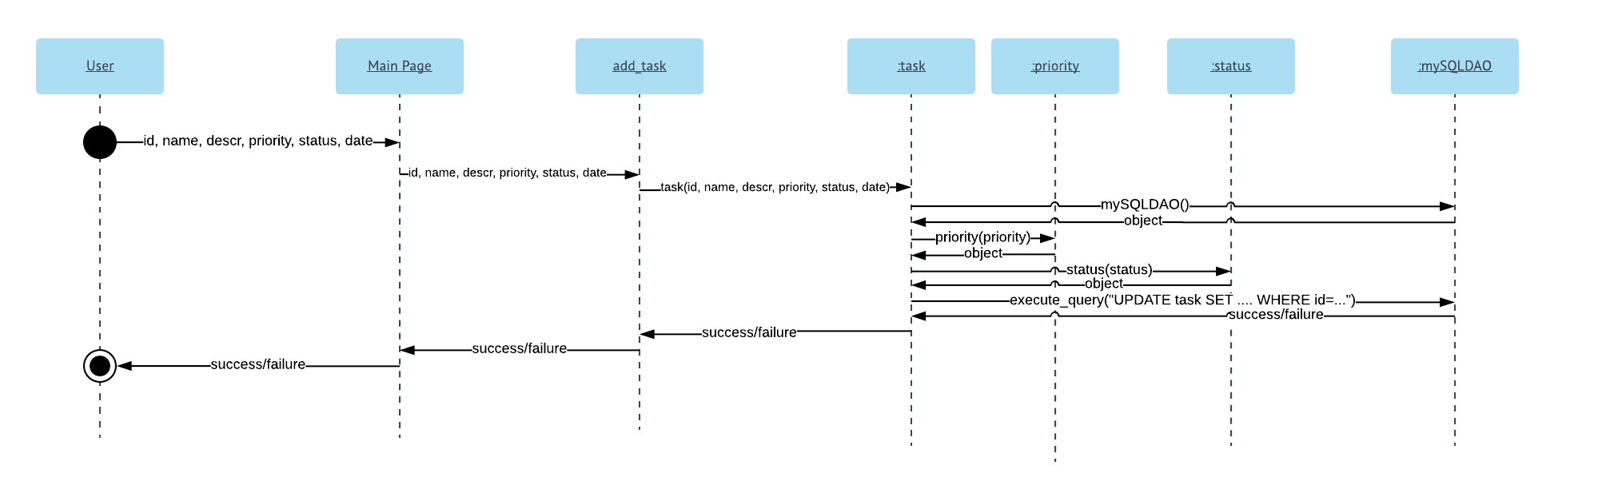

**Sequence Diagram 4 – Display All Tasks**

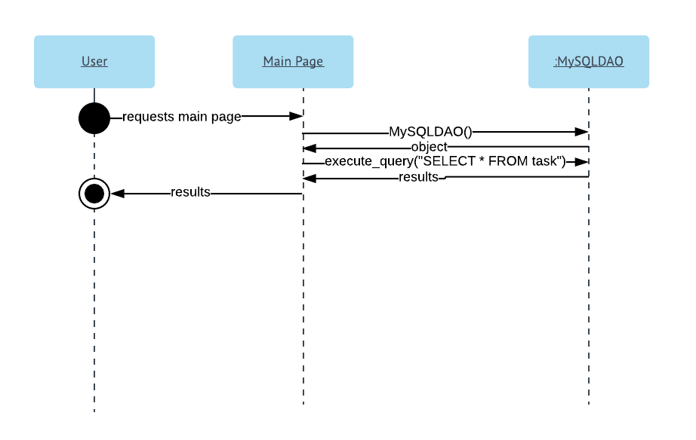

**Sequence Diagram 5 – Display All Pending Tasks**

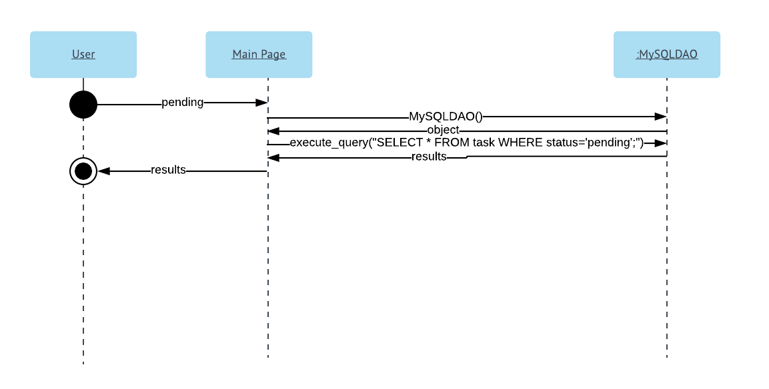

**Sequence Diagram 6 – Display All Completed Tasks**

